**BIO-103 (Sec-21)  
Department of Biochemistry & Microbiology  
North south University**

TITLE: Food Security Is Equivalent to Food Justice

Name: Townim Faisal ID: 1721327042 Date Of Submission: March 10, 2018

**Introduction:**

Food security and adequate nutrition are among the basic needs of every human being. Their fundamental importance has been underscored by the world community through the International Covenant on Economic, Social and Cultural Rights (ICESCR), which enshrines the right to food and the right to adequate nutrition, as among the inalienable rights that every human person can claim. It also makes economic sense to pay attention to food security and nutrition. No country can expect to build a thriving economy on the backs of hungry and undernourished people. According to a joint study of the Government of Bangladesh and the United States Agency for International Development (USAID), under-nutrition already costs Bangladesh more than US$1 billion in lost productivity every year and even more in health costs. Thus, if Bangladesh aspires to be a developed country by 2041 (as the government has proclaimed), it must commit to investing heavily and effectively in food security and nutrition.

**What is Food Security?**

Food security exists when all people, at all times, have access to sufficient, safe and nutritious food to maintain healthy and productive lives. The key elements of food security are:

(a) Availability of enough food from domestic production and/or imports to meet the demand, (b) Access of the food to all people at all times through enough incomes and affordable prices,

(c) Proper hygiene and sanitary practices and safe water for utilization of food to have optimum impact on health and nutrition, and

(d) A regulatory framework in place and its proper implementation for controlling contamination to ensure food safety.

At the 1974 [World Food Conference](https://en.wikipedia.org/wiki/World_Food_Conference) the term "food security" was defined with an emphasis on supply. Food security, they said, is the "availability at all times of adequate world food supplies of basic foodstuffs to sustain a steady expansion of food consumption and to offset fluctuations in production and prices"[1]. Later definitions added demand and access issues to the definition. The final report of the 1996 World Food Summit states that food security "exists when all people, at all times, have physical and economic access to sufficient, safe and nutritious food to meet their dietary needs and food preferences for an active and healthy life"[2][3].

**What is Food Justice?**

Food Justice is communities exercising their right to grow, sell, and eat healthy food. Healthy food is fresh, nutritious, affordable, culturally-appropriate, and grown locally with care for the well-being of the land, workers, and animals. People practicing food justice leads to a strong local food system, self-reliant communities, and a healthy environment. This community action can come in the form of urban of community gardens and farms, programs that educate the community about healthy food options, food drives, and much more.

It increases awareness and action in response to food insecurity and economic pressures that prevent access to healthy, nutritious, and culturally appropriate foods.

**Statistics of Bangladesh:**

Bangladesh’s high poverty and under nutrition rates are exacerbated by frequent natural disasters and high population density. In 2010, the percentage of Bangladeshis living beneath the poverty line dropped to 31.5 percent, down from 40 percent in 2005 (WFP 2012). However, more than 17 percent of the population (160 million) is still extremely poor and high levels of inequality have persisted over the same period. More than 40 million Bangladeshis are undernourished by FAO’s definition – not having access to adequate amounts of safe, nutritious food to sustain a healthy and productive life (FAO 2012). Bangladesh is ranked 129th out of 169 countries in the 2010 Human development Index (HDI), and 68th in a list of 79 countries in the 2012 Global Hunger Index (GHI). Significant gender disparities persist in health, education, and income in Bangladesh. In addition, the prevalence of acute and chronic malnutrition among children under 2 remain alarming. Achieving gender equality also remains a challenge, as significant disparities persist in health, education and income. Stunting affects an estimated 48.6 percent of the country’s 20 million children, with nearly half of children under 5 (7.8 million) experiencing stunting (Household Food Security and Nutrition Assessment 2010). An estimated 18 percent of the country’s adult women are also acutely malnourished. Bangladesh is one of the most disaster-prone countries in the world, and climate change-related disasters, such as cyclones and floods, lean season crises, and drought, are likely to continue to undermine poverty reduction efforts. The Government’s Poverty Reduction Strategy continues to address these challenges

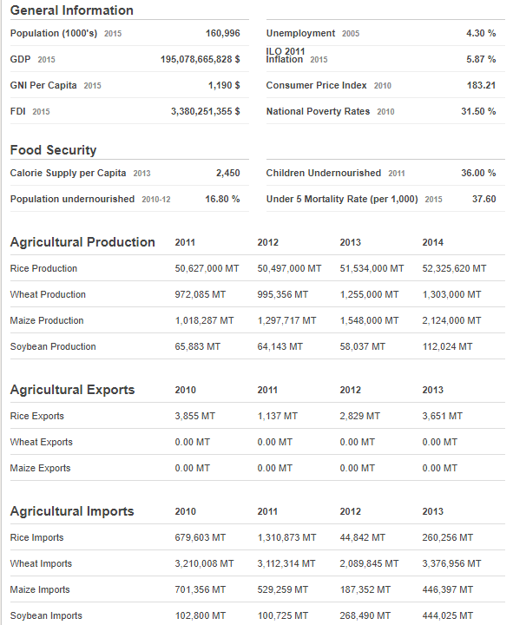

Figure: Statistics of Bangladesh Food[4]

through the National Food Policy (2006) and Plan of Action(2008-  
2015). These programs focus on the following goals: Adequate and stable supply of safe and nutritious food and increased purchasing power and access to food of the people; and adequate nutrition for all individuals, especially women and children. These goals will be achieved through intensifying investment in agricultural research and extension activities and crop and livestock diversification; strengthening rural access to markets and women’s access to productive assets; and expanding social safety net programs.

**How Food Security Is Equivalent to Food Justice:**

A few of the aspects that should be considered in food justice and food security [5]:

* **Food miles:** how far must food be transported from field to plate? Food that travels less is fresher and cheaper, in general.
* **Relational/proximate:** where does what is raised go? From whom? To whom? For what price? What is wasted?
* **Food accessibility:** how far must people go to get healthy food? How hard is it to do? Without a car? With a disability? With four children under five?
* **Economic equity:** affordable food would vary according to income, but there must be something safe, appropriate and palatable for each person in a given place.
* **Health disparities:** people who live in poverty have a significantly higher rate of most health problems, but those that relate to food include diabetes, obesity, heart disease, high blood pressure and related illnesses. Many of these diseases are specifically correlated with poor diet and cheap, highly processed foods.
* **Environmental protection:** the low price of food overall in the United States has been driven historically by the use of chemical fertilizers, herbicides and pesticides. This has allowed greater yields, but there have been environmental, genetic and financial costs that must be mitigated to avoid continued environmental damage.

There are so many issues surrounding food justice or its lack that this box could be a whole guide on its own, but the common thread is that proper nutrition is key to health, development, well-being, and cognitive and physical performance, so the ability to provide for oneself and one's family becomes a huge focus. If you are hungry, it's hard to focus on anything else. If you are full of not-very-nutritious food, then you will not feel as well or be able to perform as well as you might if you had better nutrition.

**References:**

1. [Trade Reforms and Food Security: Conceptualizing the Linkages](http://www.fao.org/docrep/005/y4671e/y4671e06.htm). FAO, UN. 2003.
2. Raj Patel (20 Nov 2013). ["Raj Patel: 'Food sovereignty' is next big idea"](http://www.ft.com/cms/s/0/584ed992-4216-11e3-9d3c-00144feabdc0.html). [Financial Times](https://en.wikipedia.org/wiki/Financial_Times). Retrieved 17 Jan 2014. ([registration required](https://en.wikipedia.org/wiki/Wikipedia:Verifiability#Access_to_sources))
3. Food and Agriculture Organization (November 1996). ["Rome Declaration on Food Security and World Food Summit Plan of Action"](http://www.fao.org/docrep/003/w3613e/w3613e00.htm). Retrieved 26 October 2013
4. <http://www.foodsecurityportal.org/bangladesh>
5. These main points are drawn largely from a conference talk by Dr. Gail Feenstra, UC Davis. Food Justice Summit, Fayetteville, AR, 2013